Malawi

## Political Stability Estimate Data

The data set shows the political stability estimate of the country each year.

## # A tibble: 19 x 5  
## country iso3c date stability stabilityCategory4   
## <chr> <chr> <dbl> <dbl> <chr>   
## 1 Malawi MWI 1996 -0.455 moderately unstable  
## 2 Malawi MWI 1998 -0.0688 moderately unstable  
## 3 Malawi MWI 2000 -0.327 moderately unstable  
## 4 Malawi MWI 2002 0.00326 moderately stable   
## 5 Malawi MWI 2003 0.0410 moderately stable   
## 6 Malawi MWI 2004 0.123 moderately stable   
## 7 Malawi MWI 2005 0.105 moderately stable   
## 8 Malawi MWI 2006 0.119 moderately stable   
## 9 Malawi MWI 2007 0.0825 moderately stable   
## 10 Malawi MWI 2008 -0.0622 moderately unstable  
## 11 Malawi MWI 2009 0.0532 moderately stable   
## 12 Malawi MWI 2010 0.0439 moderately stable   
## 13 Malawi MWI 2011 -0.0729 moderately unstable  
## 14 Malawi MWI 2012 -0.00269 moderately unstable  
## 15 Malawi MWI 2013 -0.206 moderately unstable  
## 16 Malawi MWI 2014 0.0811 moderately stable   
## 17 Malawi MWI 2015 0.0319 moderately stable   
## 18 Malawi MWI 2016 -0.113 moderately unstable  
## 19 Malawi MWI 2017 -0.272 moderately unstable

## Political Stability Estimate Plot

The plot shows the trends of stabilization and destabilization for the each country.

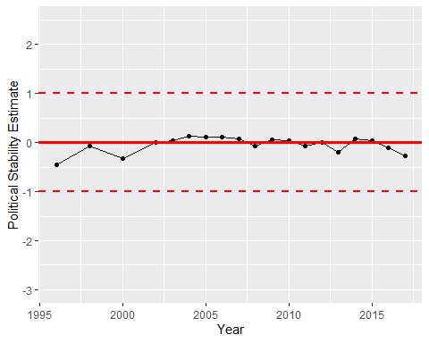

Political Stability Trend